Travlr Getaways Full Stack Web Application
CS 465 Project Software Design Document
Version 1.0
Wasiq Afzaal
April 19, 2026


Document Revision History
Version | Date | Author | Comments
1.0 | 03/21/26 | Wasiq Afzaal | Completed Milestone One sections: Executive Summary, Design Constraints, and Component Diagram narrative.
1.1 | 04/04/26 | Wasiq Afzaal | Completed Milestone Two sections: Sequence Diagram, Class Diagram, and API Endpoints.
1.2 | 04/19/26 | Wasiq Afzaal | Finalized Software Design Document by integrating milestone content, full project rubric requirements, and user interface testing narrative.

Executive Summary
Travlr Getaways uses a full stack web architecture that separates the public travel website, the administrative interface, the application logic, and the data layer so the system remains maintainable and scalable. The application is developed with the MEAN stack: MongoDB stores trip and user data, Express and Node.js provide the server-side application and RESTful services, and Angular powers the administrator single-page application (SPA). This architecture supports the client’s requirement for both a customer-facing experience and an internal management experience while keeping business data in one shared source of truth.
On the customer-facing side, travelers can browse destinations, review trip details, search available packages, and access reservation information before their trip. On the administrator side, staff can sign in to a protected Angular SPA to create trips, update trip details, manage pricing, and maintain system content without reloading entire pages. The Angular client communicates with the Express API, which applies business rules, validates requests, and reads from or writes to MongoDB. Together, these layers create an organized and extensible solution that supports both customer engagement and internal administration.

Design Constraints
The Travlr Getaways application is constrained by the required use of a web-based full stack design, the MEAN technology stack, the need to support both a public website and an administrator SPA, and the expectation that all major parts of the solution work together through a consistent data model. The design must also support secure administrator access, reliable API communication, browser-based usability, and a structure that can be maintained throughout future enhancements. In addition, the application should remain practical to deploy and test in a course development environment while still reflecting real-world full stack practices.
These constraints directly shape the development approach. Because both the customer site and the admin SPA rely on the same trip information, the database schema and API endpoints must be designed carefully so content remains consistent across both interfaces. The requirement for secure administration means authentication and protected routes must be added for admin functions, which increases implementation complexity compared with a basic public website. The browser-based nature of the system also places importance on responsive design, clear navigation, and lightweight data exchanges between the front end and the API. Finally, the use of MEAN encourages modular development, where each layer has a defined role but still requires careful coordination and testing so the user interface, server logic, and database interactions stay synchronized.

System Architecture View

Component Diagram
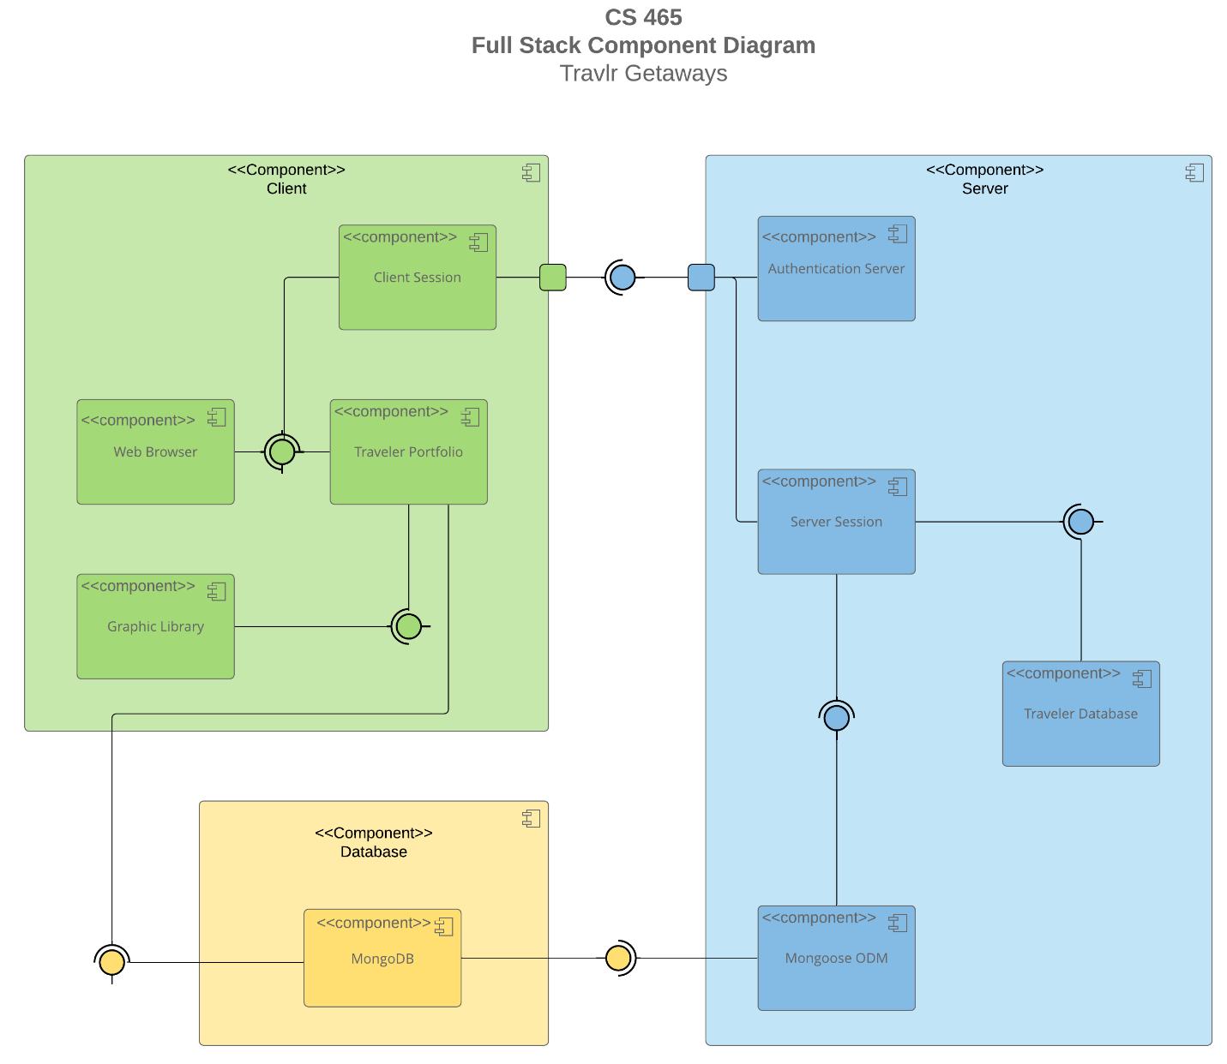
Figure 1. Travlr Getaways component diagram.
The component diagram shows a multi-tier web application in which each major function is separated into focused components that communicate through clear interfaces. At the presentation layer, the customer-facing website allows travelers to browse trip content and view destination information, while the administrator SPA provides an authenticated interface for managing trip data. Both front-end components communicate with the Node.js and Express application layer. This middle tier handles routing, controller logic, API requests, validation, and the translation of client actions into database operations.
The server layer connects to MongoDB, which stores persistent application data such as trip records, bookings, and administrator credentials. In this relationship, MongoDB serves as the system of record, Express and Node.js act as the service and business logic tier, and the customer and admin interfaces function as separate clients of that shared backend. This arrangement is significant because it allows the public website and the administrator SPA to remain independent in presentation while still using the same core data. As a result, updates made by an administrator can be surfaced to customers through the same centralized architecture, improving maintainability, consistency, and scalability.

Sequence Diagram
Figure 2. Request-response flow across the application stack.
The sequence diagram illustrates the flow of communication between the client, server, and database layers in the Travlr Getaways web application. The interaction begins when a user initiates a request through a browser or HTTP client. The browser sends an HTTP request to the Express route handler. The routing layer forwards the request to the appropriate controller, which processes the request and communicates with the model layer. The model interacts with MongoDB to retrieve or update data. The response is then sent back through the controller and route to the client interface.
For sign-in activity, the browser submits administrator credentials to a protected login route. The controller validates the request, checks the stored user record, and returns an authentication token when the credentials are correct. For trip-related interactions, the browser requests trip data through a trips route, the controller queries the trip model, and MongoDB returns the matching records. For administrator updates, the Angular SPA sends a create, edit, or delete request through a protected API endpoint. The server validates the JSON Web Token, applies the requested change through the model, updates MongoDB, and returns a confirmation response to the SPA. These interactions show how presentation, logic, and data tiers work together in the full stack application.

Class Diagram
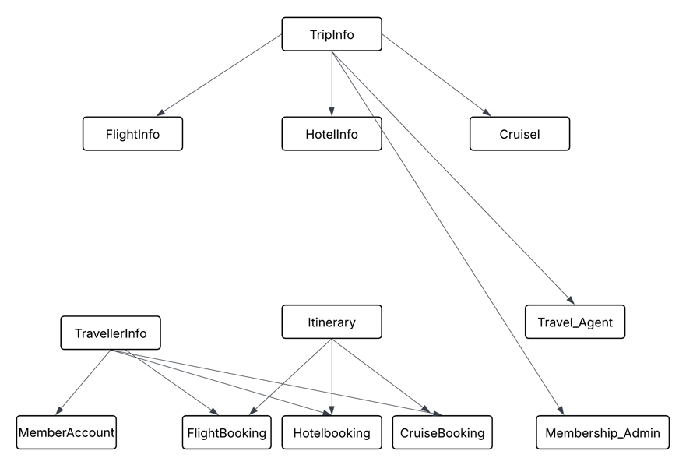
Figure 3. Core JavaScript classes and relationships.
The class diagram represents the structure of the JavaScript objects used in the Travlr Getaways application. TripInfo acts as the central entity that connects travel-specific classes such as FlightInfo, HotelInfo, and CruiseInfo. TravellerInfo stores customer data and is associated with MemberAccount for authentication and account access. Booking classes, including FlightBooking, HotelBooking, and CruiseBooking, represent the user’s travel transactions, while the Itinerary class organizes those bookings into one travel plan.
Administrative classes such as Travel_Agent and Membership_Admin reflect the internal management functions of the application. These roles support trip maintenance, content updates, and customer-account administration. The class structure supports separation of concerns because trip content, traveler identity, bookings, itineraries, and administrative controls are modeled as related but distinct objects. This helps the application remain easier to extend as more services or trip packages are added.

API Endpoints
The RESTful API exposes the core operations needed for retrieving trip data, authenticating administrators, and managing bookings and trip records. These endpoints allow the application to integrate the front end, server logic, and MongoDB storage layer through a consistent request model.
Method | Purpose | URL | Notes
GET | Retrieve all trips | /api/trips | Returns all available trips for display in the public site or SPA.
GET | Retrieve a single trip | /api/trips/:tripId | Returns one trip record by unique identifier.
POST | Create a trip | /api/trips | Protected admin route used to add a new trip package.
PUT | Update a trip | /api/trips/:tripId | Protected admin route used to modify trip details.
DELETE | Delete a trip | /api/trips/:tripId | Protected admin route used to remove an obsolete trip.
POST | Admin login | /api/login | Authenticates admin credentials and returns a JWT.
POST | Create booking | /api/bookings | Creates a booking record for a traveler.
GET | Retrieve user bookings | /api/bookings/:userId | Returns bookings tied to a specific user account.
PUT | Update booking | /api/bookings/:bookingId | Edits an existing reservation or itinerary record.
DELETE | Delete booking | /api/bookings/:bookingId | Cancels a booking and removes the record.

The User Interface

Required SPA Screenshots
Required View | Submission Note
Unique trip added by you | Insert your final SPA screenshot showing a new trip record created for testing.
Edit screen | Insert your screenshot of the SPA edit form with existing trip data loaded.
Update screen | Insert your screenshot showing the updated trip after a successful PUT request.

The Angular project structure is organized around components, services, routing, and models, which makes it well suited for a single-page application. Components handle presentation and user interaction, services manage communication with the REST API, and routing enables users to move between views without a full page reload. This differs from the Express project structure, which is organized around routes, controllers, views, and models. In Express, routes define the request paths, controllers process requests, views render server-generated output for the customer-facing site, and models manage data access through Mongoose.
The SPA provides richer functionality than a traditional server-rendered web application because the administrator can create, edit, and delete trips with more immediate feedback and less page refresh behavior. The Angular client can bind form fields directly to component data, validate input before submission, and update displayed information after the server responds. This makes the admin workflow faster and more interactive than a simple request-render-response cycle.
Testing the SPA with the API focuses on confirming that GET and PUT requests behave correctly. First, the application is run with the Node.js and Express server connected to MongoDB so existing trip data can be retrieved through the API. The Angular admin client then issues GET requests to populate the travel list and individual edit views. To test updates, a trip record is selected in the SPA, the form values are changed, and a PUT request is submitted to the protected endpoint. The test is successful when the API returns a confirmation, the updated data persists in MongoDB, and the revised values immediately appear in the Angular interface. Additional testing should confirm that authentication protects admin-only routes and that invalid or unauthorized requests are rejected.

Final Submission Summary
This final Software Design Document combines the work completed throughout the course into one unified project submission. Milestone One supplied the Executive Summary, Design Constraints, and Component Diagram explanation. Milestone Two supplied the Sequence Diagram, Class Diagram, and API Endpoints. The final project version integrates those milestone sections into the provided SDD template and adds the completed User Interface narrative so the document addresses the full project rubric in one place.
For the final submission package, the completed SDD should be turned in alongside the final zipped application folder, typically named travlr.zip. The zip file should contain the completed Travlr Getaways MEAN-stack project, including the customer-facing Express application, the Angular administrator SPA, the MongoDB-connected backend, and the implemented authentication features.

